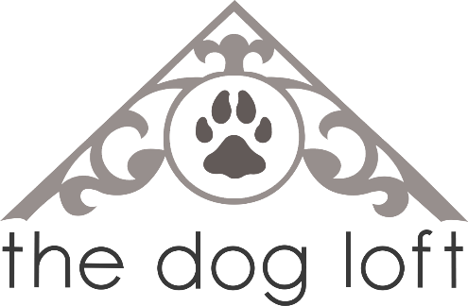
Puppy Play Registration Form

Name: ________________________________________________________________________
Address: ______________________________________________________________________
City: __________________________________ Postal Code: ____________________________
Phone: ________________________________ Phone: ________________________________
Email: ________________________________________________________________________
Would you like to receive our monthly e-newsletter?: YES / NO

Dog’s Name: ______________________________________ Age: ________________________
Breed: ___________________________________________ Size: SMALL LARGE

I understand that my attendance in dog socialization is not without risk to myself, my dog, my family and guests, and other class participants (both human and canine). I agree that, as owner of the above dog, I am solely responsible for their behavior and agree to carefully monitor and control my dog at all times. I understand that The Dog Loft Inc. and all of its agents will not be held liable, financially or otherwise, for any and all forms of injury to myself or my pet, and I expressly assume the risk of such damages, losses, or injuries resulting from the act or omissions of any and all other dogs or dog owners on the premises where the sessions are held. I agree to follow and respect all rules and regulations set out by the instructor and by The Dog Loft Inc. and it’s agents.

Signature: __________________________________________________ Date: ____________________
FOR EMPLOYEE USE:
Session: ____________________________________ Trainer: _________________________________
Parvo: ____________________________________ Distemper: ________________________________

