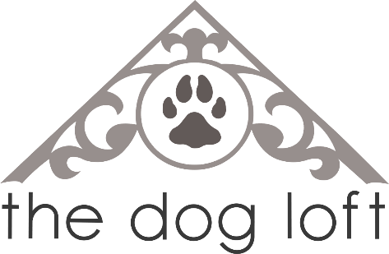

AGGRESSION POLICY

The Dog Loft Inc. has a zero-tolerance policy regarding aggression of any type. We reserve the right to temporarily or permanently remove any dog from daycare at any time. Unprovoked aggressive behaviour will result in a permanent ban from participating in any services at The Dog Loft.
The Dog Loft Inc. is not a rehab facility, nor do we provide any behaviour conditioning services. It is expected that all dogs who choose to take part in daycare activities have shown no signs of aggression towards humans or other dogs. The Dog Loft Inc. does not tolerate any exhibitions of excessively dominant behaviour, toy aggression, or head control aggression when being handled. It is our utmost priority to ensure the care of all dogs in our facility and it is important that we are able to do so safely.
If you are aware of any concerns with your dog regarding handling, toys, or reactive behaviour please inform the staff before leaving your dog in our care.

SPAY / NEUTER POLICY

All dogs over the age of 8 months must be spayed/neutered in order to participate in daycare at The Dog Loft Inc.
Excessive humping is not tolerated and will result in the removal of your dog from daycare. If your dog is under the age of 8 months and removed from daycare for excessive humping behaviour, your dog may return to daycare upon such a time that he/she has been neutered/spayed. Females in heat are not permitted in daycare under any circumstances.

