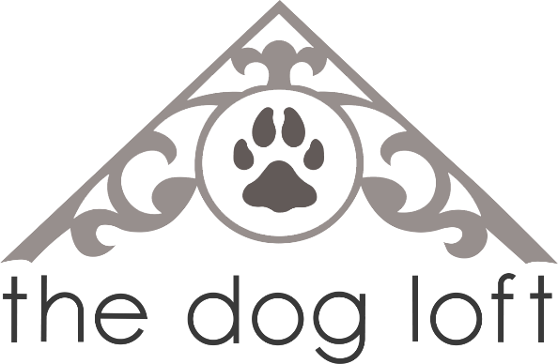
Class Registration Form

Name: ________________________________________________________________________
Address: ______________________________________________________________________
City: ____________________________________ Postal Code: ___________________________
Phone: _________________________________ Phone: ________________________________
Email: ________________________________________________________________________
Dogs Name: ________________________________ Breed: _____________________________
Age: ____________________________ Please Circle: SPAYED NEUTERED INTACT

I understand that there is a risk to myself and my dog in participating in training class. I agree to not hold The Dog Loft Inc. and its employees or agents responsible for any injury to myself or my dog incurred through my participation in class.
Print Name: ___________________________________ Date: ___________________________

Signature: _____________________________________________________________________
Do we have permission to send you our monthly e-newsletter? YES or NO

EMPLOYEE USE:
Session: _______________________________ Day/Time: ______________________________
Trainer: ____________________________________ Payment: __________________________
Rabies: ___________________ Parvo: __________________ Distemper: __________________
Employee: _____________________________________________________________________

